Experimental Determination of ORIC Harmonic Coil Polarities

Jim Ball, Carl Dukes, Ed Hudson, Dick Lord, Alan Tatum
November 18, 2004

To resolve the uncertainty of whether the harmonic coils and valley coil are configured to add or subtract from the main ORIC filed, a physical measurement was performed on November 18, 2004.

To perform these measurements, a Group 3 Hall Probe was attached to an aluminum “wand” that was inserted into the ORIC median plane through the openings in the vacuum enclosure where the ion source is normally inserted. A sketch of the wand is shown on the following page (a copy of page 129 of the Log Book). For the measurement of harmonic coil C1, the probe was attached to the end of the main part of the wand. For the measurement of the valley coil C4, the probe was attached to the end of the hinged arm that could be lowered or raised by means of a nylon cord.

The position of the wand inside the ORIC field for the two measurements is shown on the fold-out scale drawing. For both measurements, the wand was assembled and inserted into the field in the position indicated by the green line. The wand was then raised to the position indicated by the red line to make the measurements. This procedure was required by the presence of the extracted ion source assembly which is not shown on the drawing.

For both measurements, the main field coil was loaded to 500 amps and allowed to stabilize. The harmonic coil was then set to a current indicated as positive on the control system display. For harmonic coil C1 the current was 40.5 amps and for the valley coil (C4) the current was 200.5 amps. The results of these measurements is summarized in the following table:

Wand  Position | Main Coil | Main + HC | Harm. Coil | JBB Est.
C1 | 4.167 kG | 4.101 kG | -75 Gauss | ±70 Gauss
C4 | 3.040 kG | 2.813 kG | -227 Gauss | ±210 Gauss

The last column is an estimate made by extrapolating from the fields calculated (for higher currents) by the Cleary programs.

The results of the measurements show that the harmonic coils and valley coils are configured to subtract from the main field when the indicated currents are positive. This is consistent with the input to the Cleary programs which produce a decrease in the average field profile for a positive current input to the harmonic coil offsets.

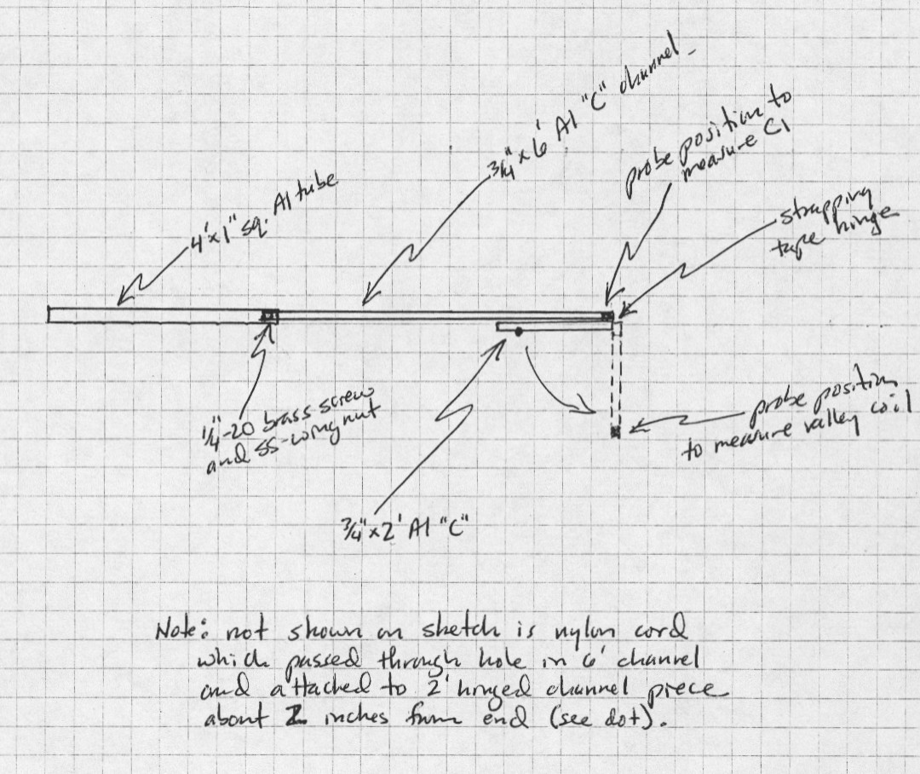

Sketch 1. Schematic of field measurement wand.

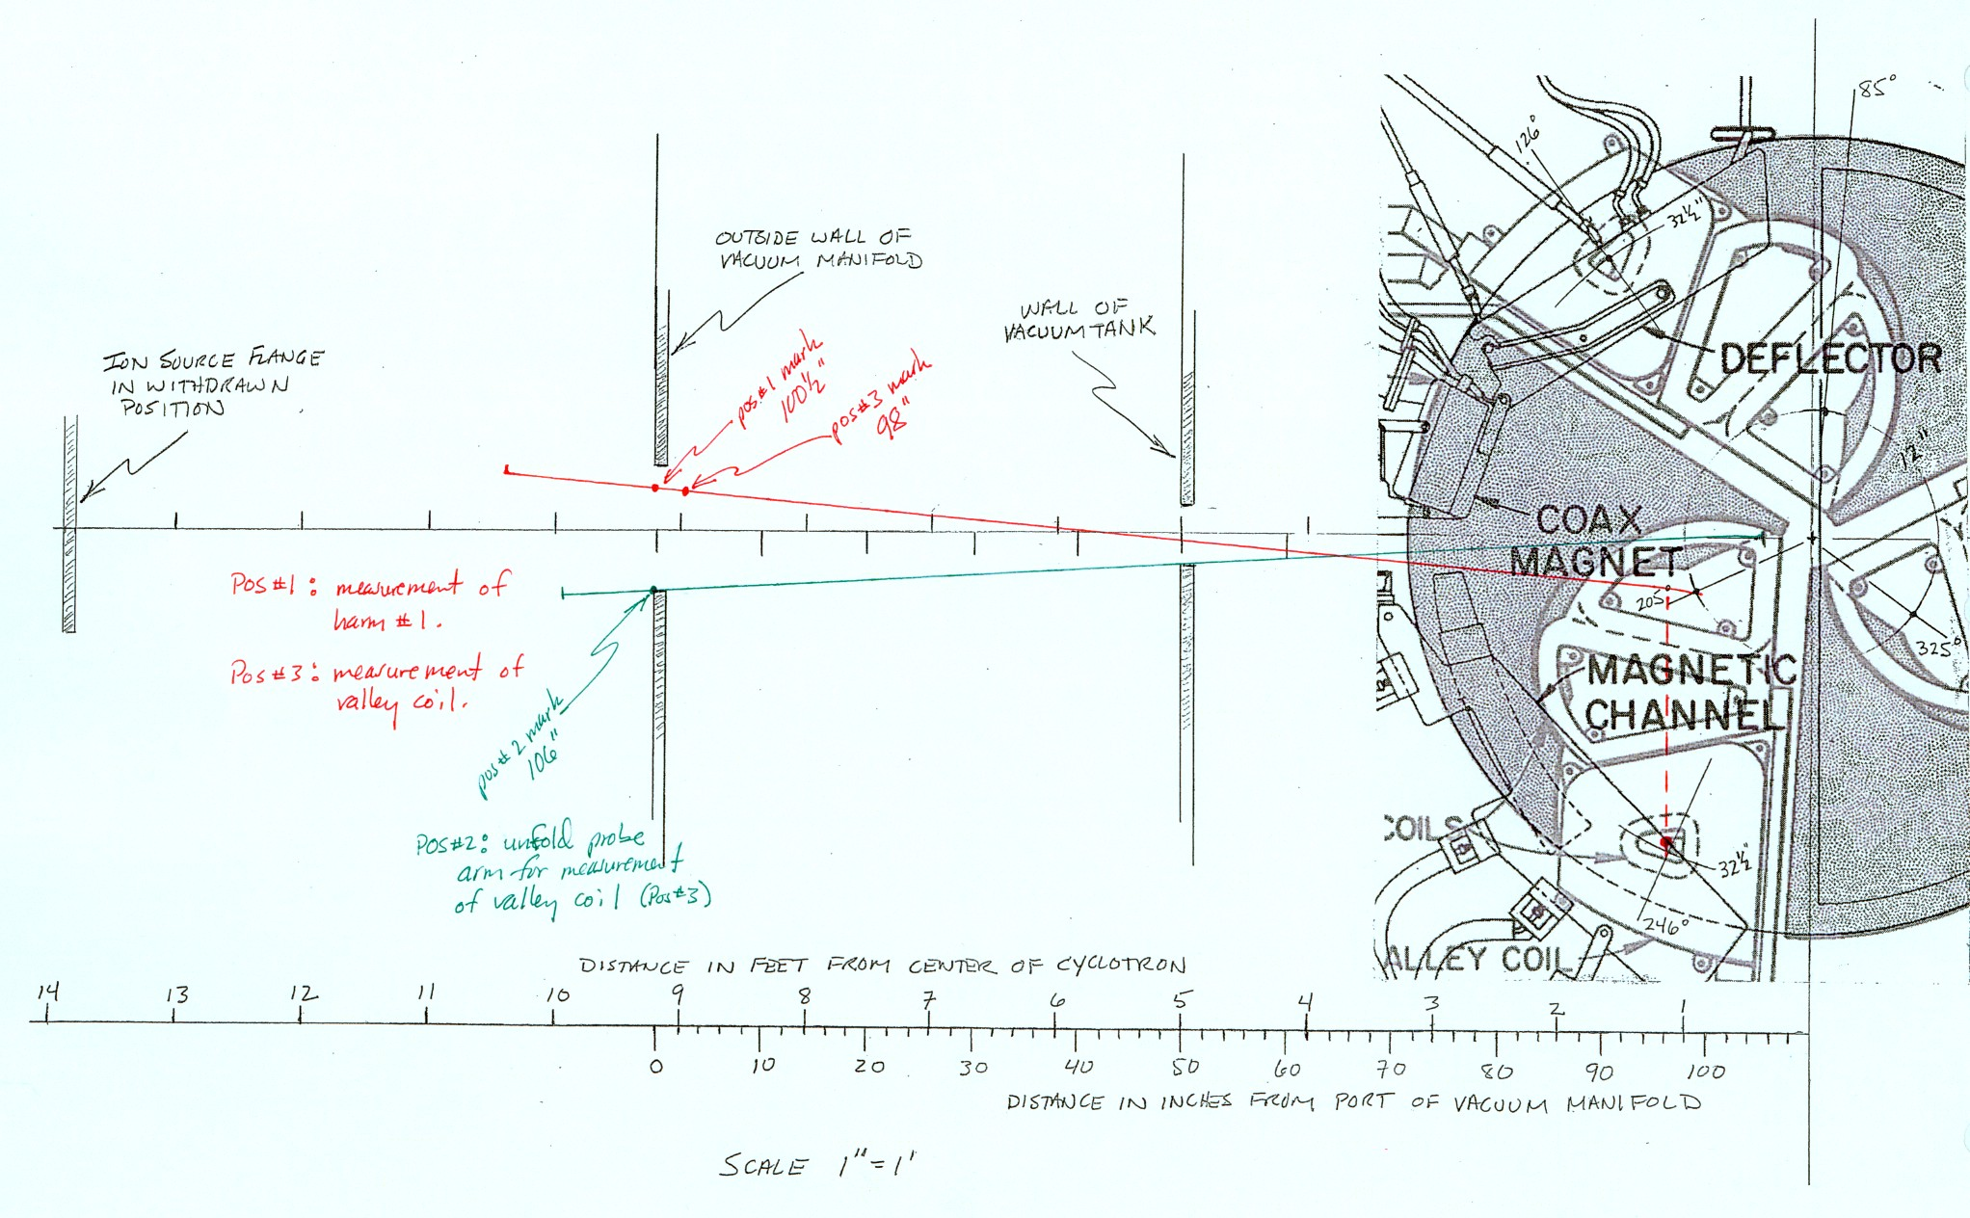

Sketch 2. This is a reduced scale reproduction of the original drawing made on an 11 x 17 inch sheet with a scale of 1inch = 1 foot. Note that this reproduction is not to scale. The probe positions are indicated by the red and green lines and labels as discussed in the text.

